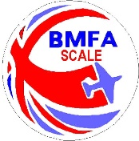 | KIT SCALE PRECISION RECORD SHEET 2023 | 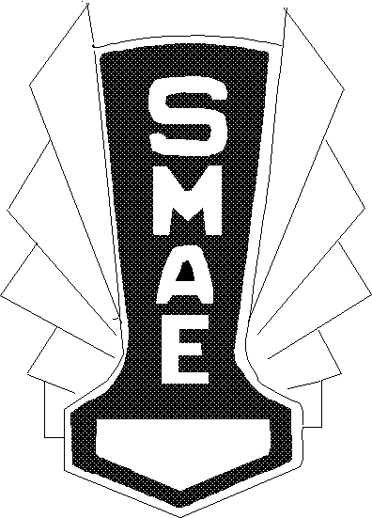
Event / Date
………………….
Name | BMFA | Model | 1 | Diff | 2 | Diff | 3 | Diff | Total | Place

